Answer to the functionality question

JS is a “language” created specifically for the purpose of interactivity and such provides many advantages to any self respecting web developer. In order to hammer this point further I endeavor to present 5 cases of its usage

1.Ajax: anyone who has ever used youtube or gmail would notice that not evry quarry/action requires a reload to get an answer/reaction this is due to ajax


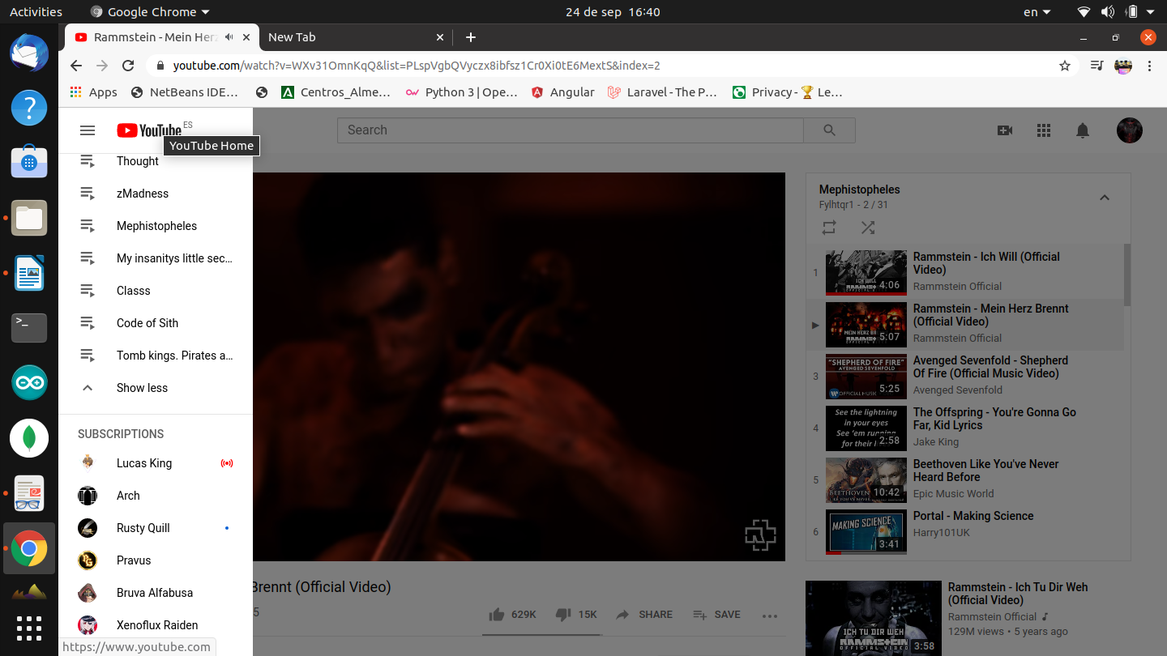

2.Which brings us to the point that it allows the capture of actions such as mouse clicks or keypresses with a degree of ease
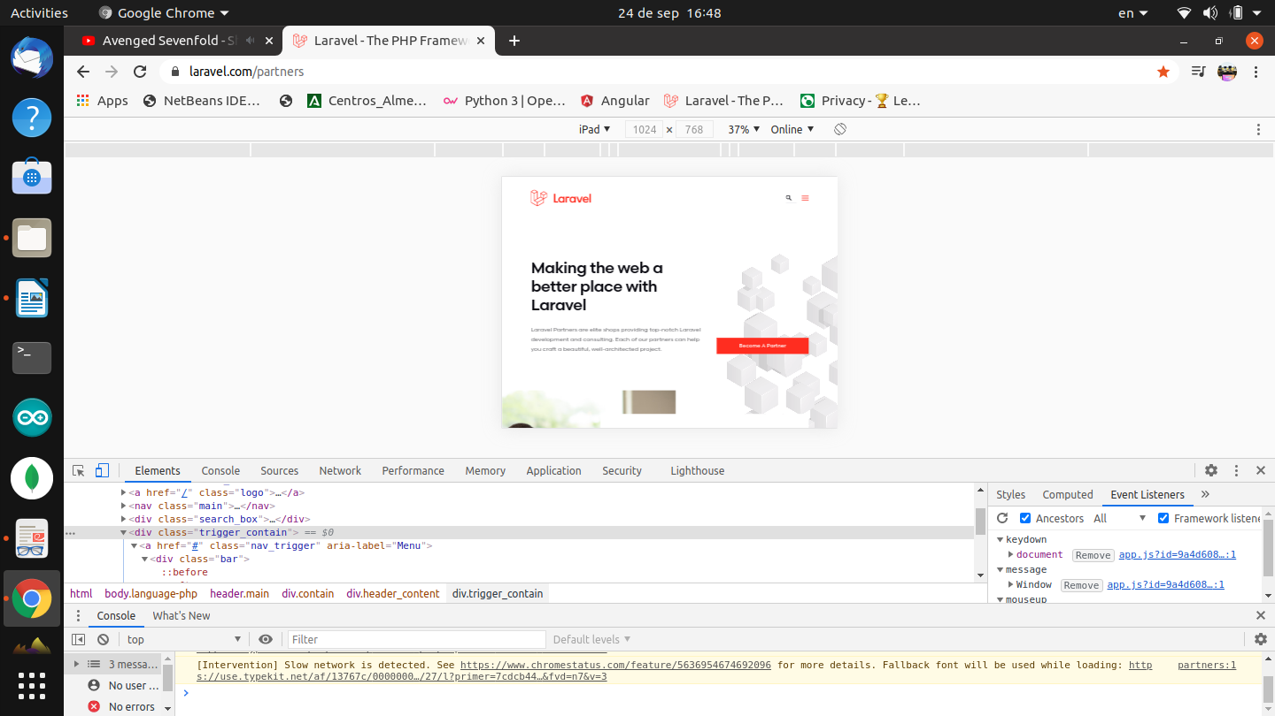
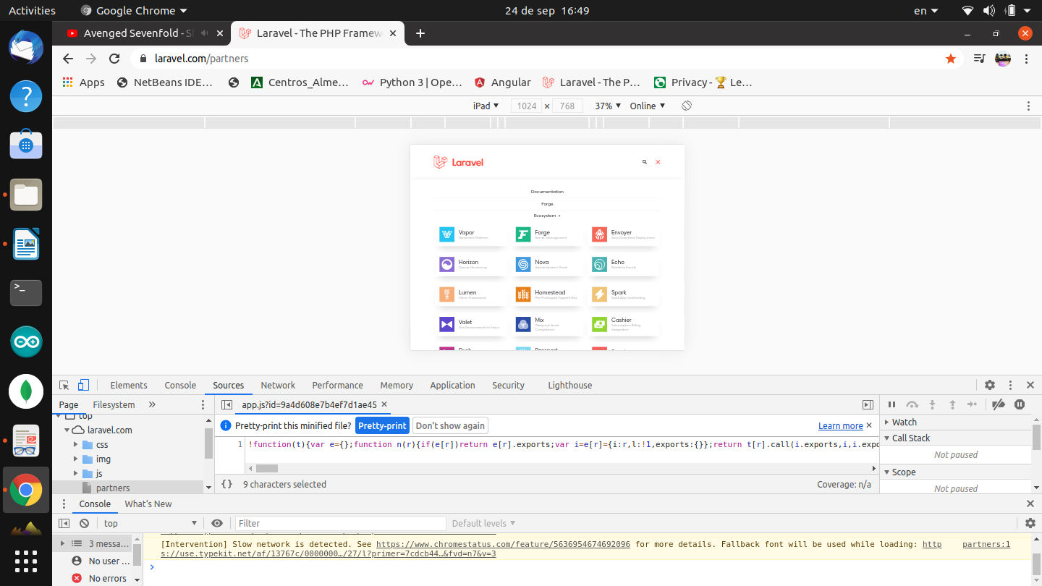

3.Some applets,frameworks and others rely on plugins for this language
such as Jquerry and Jquerry UI

4.It allows for prepossessing of data on the client end sparing the server the strain or hiding needles details from the client.
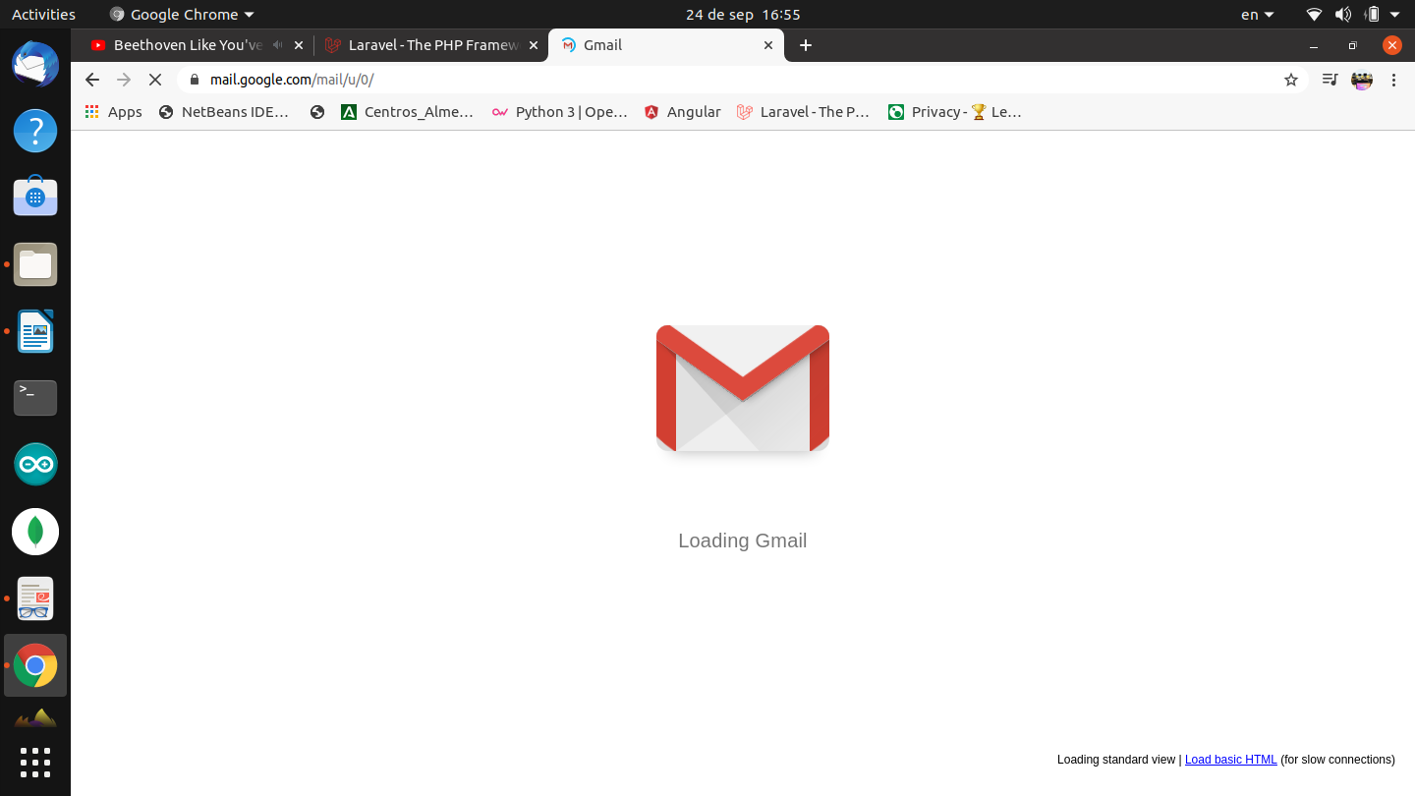
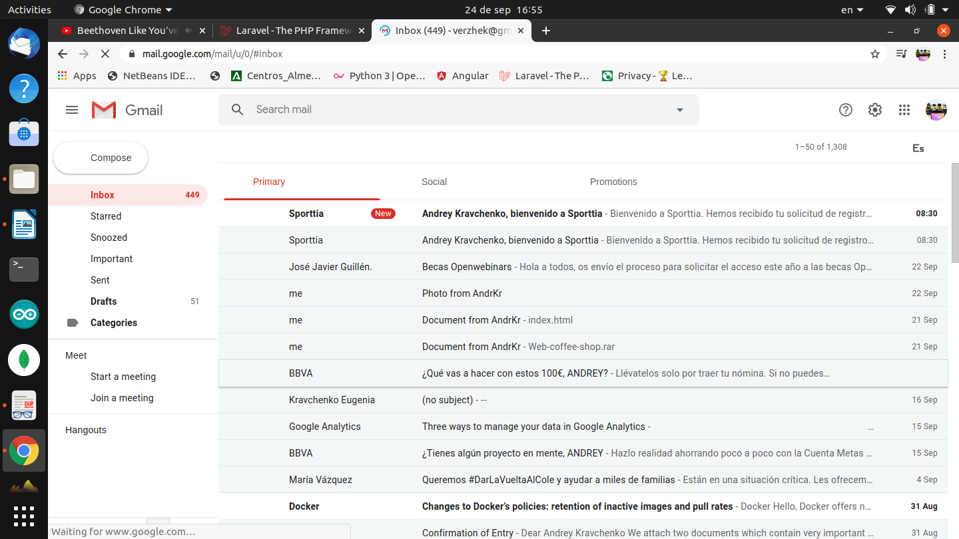

5.And as seen with previous examples it changes a great deal of navigating expirience

